**PROGRESS REPORT -2**

**Hackathon Topic:** Resturant

* Technologies used are **HTML, CSS, BOOT STRAP**.
* External file included are **Font awesome, Google Fonts**
* Images includes are from website: <https://pixabay.com/> and <https://unsplash.com/s/photos/food>.
* Used <https://www.canva.com/> to create a **Menu Card.**

**Work Description:**

**HEADER & NAVBAR:**

I have created a navigation bar and change their text using Google font, applied some CSS on it and uploaded image for home page. In home page I have used animation over pictures and created a light box which contains a menu card.

**Work Screenshots**

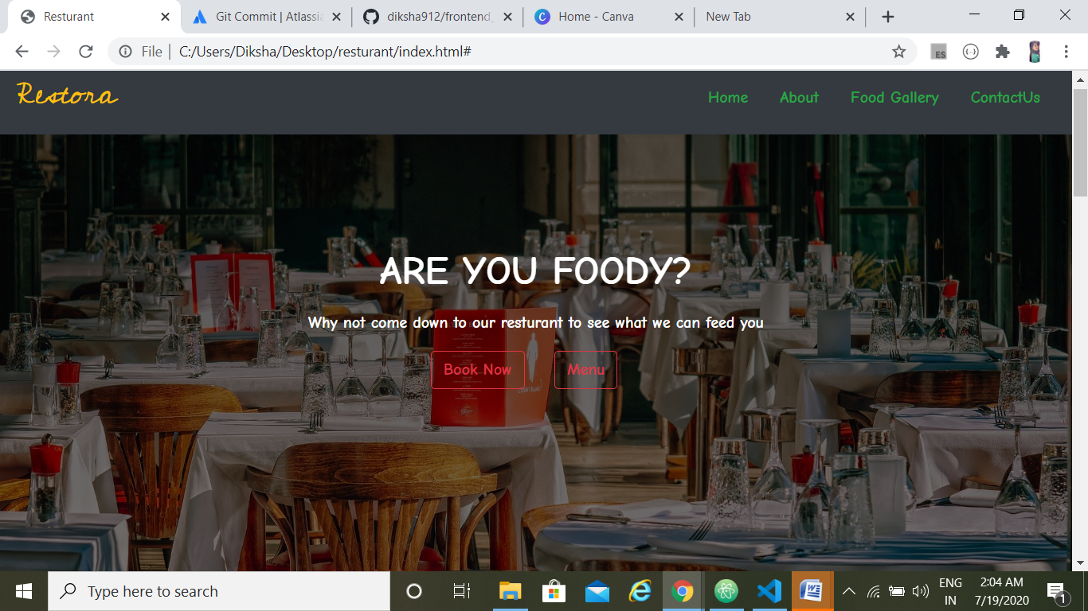

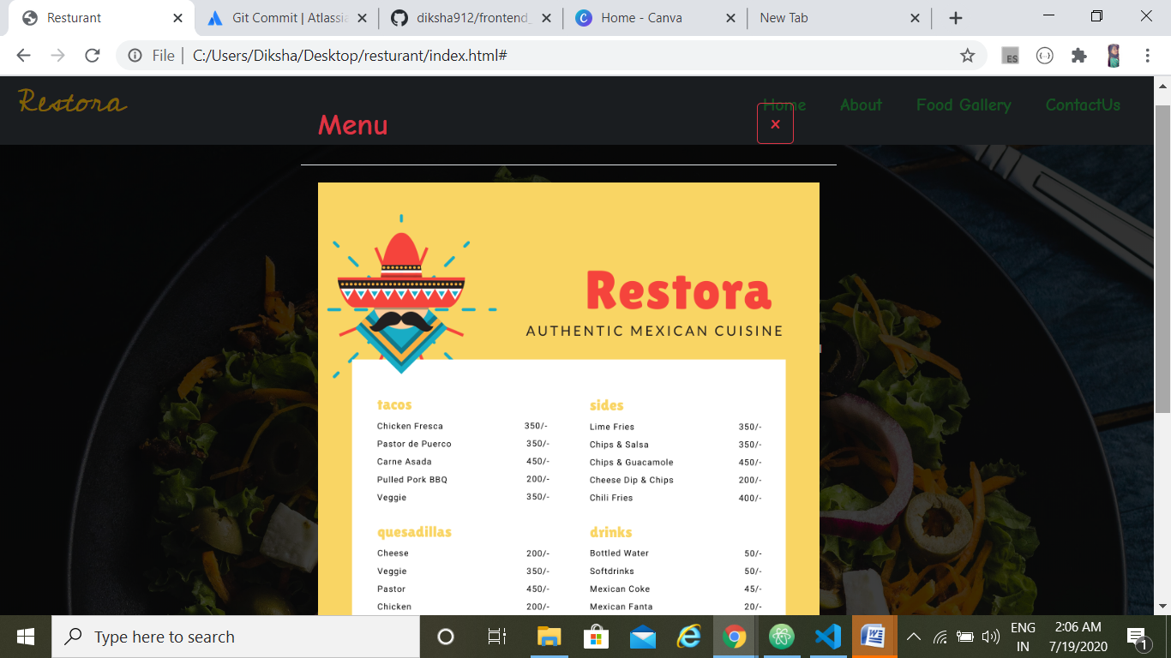

**ABOUT SECTION:**

This section includes information about the restaurant with image.

**Work Screenshots**

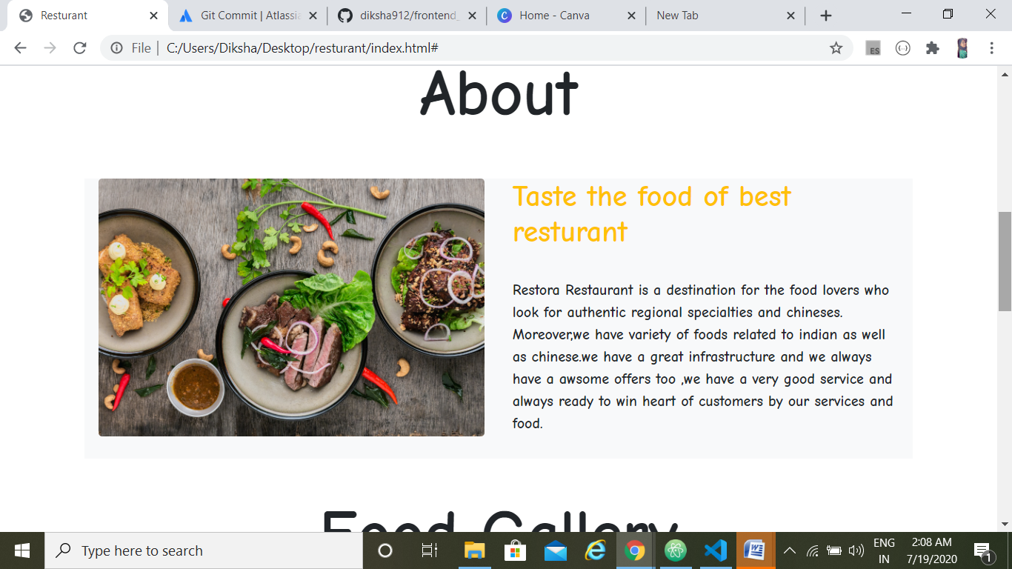

**FOOD GALLERY:**

This section is a food gallery which contains variety of foods with its content and I used a next and previous effect to make a gallery attractive it act as a slider.

**Work Screenshots**

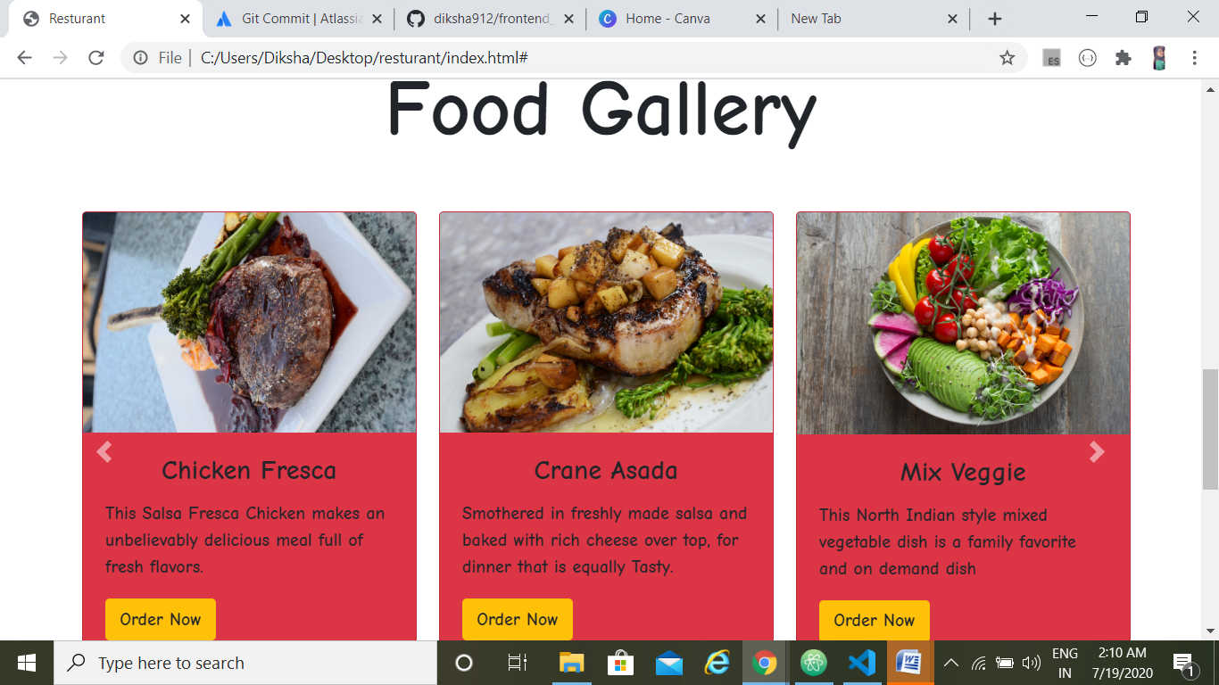

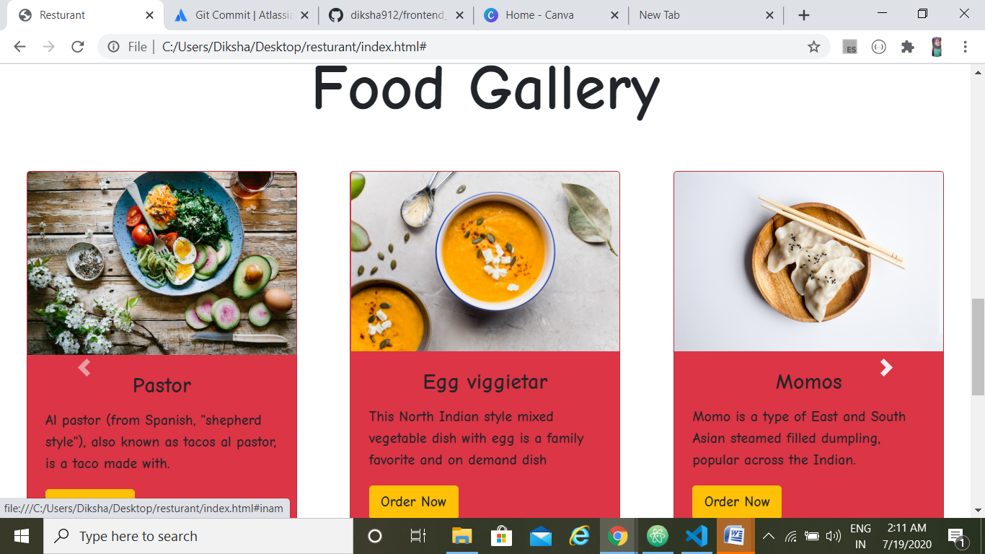

**CONTACT US:**

This section includes information about restaurant details like where it is situated and this section also asked the details of users who want to contact to the restaurant for that I have make use of forms.

**Work Screenshots**

